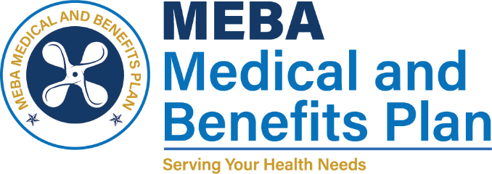 | 1007 Eastern Avenue  Baltimore, MD 21202-4345  Phone (410) 547-9111  www.mebaplans.org

Request for Amendment of Protected Health Information

As required by the Health Information Portability and Accountability Act of 1996 you have the right to request that health information that pertains to you be amended if you believe that it is incorrect or incomplete. The MEBA Medical and Benefits Plan will review your request and either grant your request or explain the reason why it will not be granted. In the event that your request is not granted you have the right to submit a statement of disagreement that will accompany the information in question for all future disclosures.

Amendment Request Section
I, (print name) hereby request that the MEBA Medical and Benefits Plan amend the following health information pertaining to me (describe the information that you believe is incorrect or incomplete):

I believe that the information described above is incomplete or incorrect for the following reasons:

I believe that the correct information is as follows:

Additionally, I request the following people or organizations be notified of the correction (please provide names and addresses):

Signature Date

If the request for amendment is denied, you may append a written statement of disagreement by completing the appropriate section of this form. You may also request that this form be included with any subsequent disclosures by initiating the appropriate line in the section reserved for statements of disagreement. You may also register a formal complaint by completing the enclosed Complaint Form and submitting it to the attention of the Privacy Official at the address shown on page 1.
Review Section
This section is to be completed by the reviewer:
Date Received: |  | Reviewed By:
Date Reviewed: |  | Title:

This request for amendment is:
- Granted
- Denied; information is accurate and complete as is
- Denied; information did not originate here
- Denied; information is not part of designated record set
- Denied; information is not available for inspection
Reviewers’ Comments:

Signature Date
Statement of Disagreement Section
(initial) I wish for this request for amendment to be included with all future disclosures of my health information.
I disagree with the stated reason for denial and my reasons for disagreement are as follows:

Signature Date
Rebuttal Section
The MEBA Medical and Benefits Plan offers the following statement in rebuttal:

Signature Date

