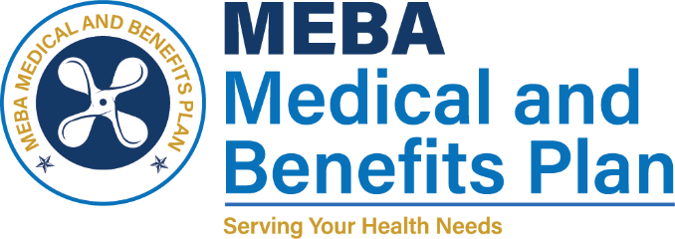 | 1007 Eastern Avenue  Baltimore, MD 21202-4345  Phone (410) 547-9111  www.mebaplans.org

Request for Accounting of Disclosures of Protected Health Information

As required by the Health Information Portability and Accountability Act of 1996 you have a right to request an accounting of disclosures of health information that pertains to you. You may not receive an accounting of such disclosures that occurred before April 14, 2003.

The accounting you may receive will not identify the following disclosures: (i) those made to carry out treatment, payment, or healthcare operations; (ii) those made to you; (iii) those that are incident to a permitted or required use or disclosure; (iv) those made pursuant to an authorization; and (v) certain disclosures to government and/or law enforcement personnel.

Request Section

I, (print name) hereby request an accounting of disclosures of my protected health information that have occurred over the last .
indicate time period (maximum of six years)

Signature Date

Request Processing Section

This section is to be completed by the reviewer:
Date Received: |  | Reviewed By:
Date Reviewed: |  | Title:

The request disclosure account was processed
Date

Signature Date

