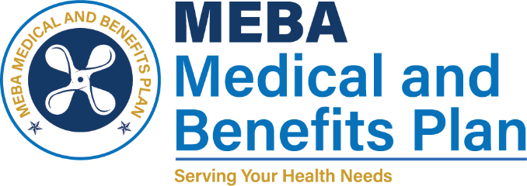 | 1007 Eastern Avenue  Baltimore, MD 21202-4345  Phone (410) 547-9111  www.mebaplans.org

Restriction Request

As required by the Health Information Portability and Accountability Act of 1996, you have a right to request restrictions on the uses and disclosures of your protected health information as described in our Notice of Privacy Practices. The MEBA Medical and Benefits Plan will make an effort to accommodate reasonable requests.

Restriction Request Section

I, ___________________________________ (print name) hereby request the following restrictions on the uses and disclosures of my health information (please describe the requested restrictions in detail):

Signature Date

Reviewer Section

The terms of this request are / are not (circle one) acceptable.

Signature Date

Print Name Title

Reviewer’s comments:

The individual has / has not (circle one) been informed of the decision in writing (attach copy of the letter).

This restriction has been terminated on ___________________ by the individual / the MEBA Medical and Benefits Plan (circle one). (date)

The individual has / has not (circle one) been informed of the termination in writing (attach copy of the letter).

