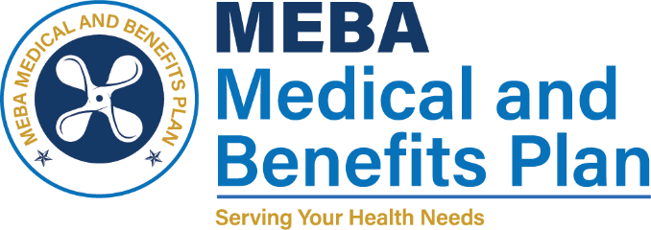 | 1007 Eastern Avenue  Baltimore, MD 21202-4345  Phone (410) 547-9111  www.mebaplans.org

Designation of Health Information Recipient

As required by the Health Information Portability and Accountability Act of 1996 you have a right to nominate one or more people to receive certain health information that pertains to you, as relevant to such person’s involvement in your health care or payment for such health care. By completing this form, you are informing us of your wish to designate the named person as a health information recipient. You may revoke this designation at any time by signing and dating the revocation of your copy of this form and returning it to this office.

Designation Section
I, (print name) hereby designate the following person to receive and/or disclose health information that pertains to me, as relevant to such person’s involvement in my healthcare or payment for such health care:

Print Name of Recipient Relationship to You

This person is to be afforded all the privileges that would be afforded to me with respect to having access to my health information.

I understand that I may revoke this designation at any time by signing the revocation section of my copy of this form and returning it to the MEBA Medical and Benefits Plan at the address shown above, I further understand that any such revocation does not apply to the extent that persons authorized to use or disclose my health information have already acted in reliance on this designation.

Signature Date

Revocation Section

I hereby revoke the designation of the individual identified above as a health care information recipient.

Signature Date

