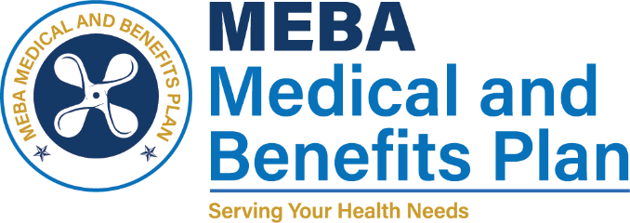 | 1007 Eastern Avenue  Baltimore, MD 21202-4345  Phone (410) 547-9111  www.mebaplans.org

Confidential Communications Request

As required by the Health Information Portability and Accountability Act of 1996 you have the right to request that communications concerning your personal health information be made through confidential channels. The MEBA Medical and Benefits Plan will do its best to accommodate all reasonable requests.

I, (print name) hereby request the use of confidential channels for the communication of information related to my personal health or payment for treatment. I believe that a disclosure of my personal health information other than through confidential communications endangers me.

Description of special communication methods to be used (Please specify alternate telephone numbers, alternate mailing addresses, etc.):

Signature Date

